INSTAGRAM USER ANALYTICS

TASK 1- TO CREATE A DATABASE

A database “ig_clone” is created in SQL workbench. Commands used are-

* create database ig_clone; -> to create the database
* show databases; -> to display all the databases present in the system
* use ig_clone; -> to use the database ig_clone

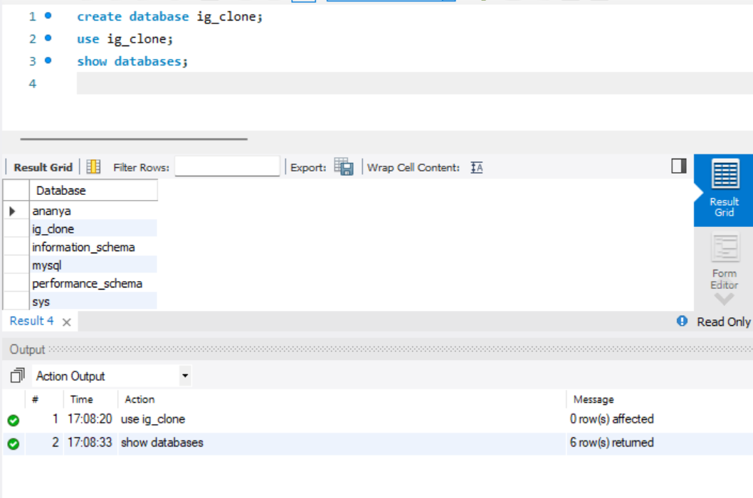

TASK 2- TO CREATE TABLES AND INSERT THE DATA

Now as the database is created in SQL workbench, the data has to be entered in it in the form of tables. To create tables a “create table……..” command is used, for example:

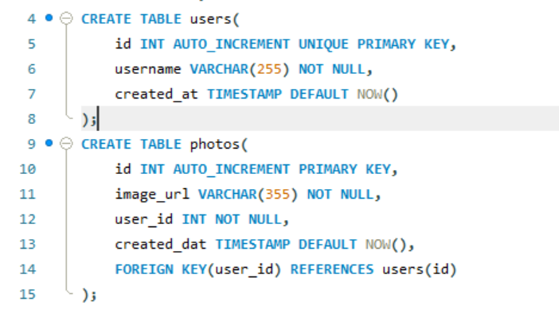

And to insert the data in the table “insert into table…..” command is used, for example:

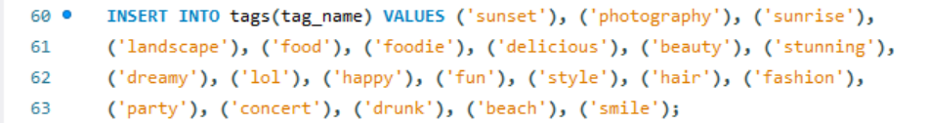

TASK 3- MARKETING ANALYSIS

1. **LOCAL USER REWARD:** List of 5 oldest users of Instagram

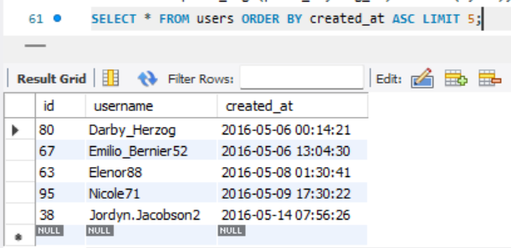

1. **INACTIVE USER ENGAGEMENT:** List users who never posted even a single photo on Instagram.

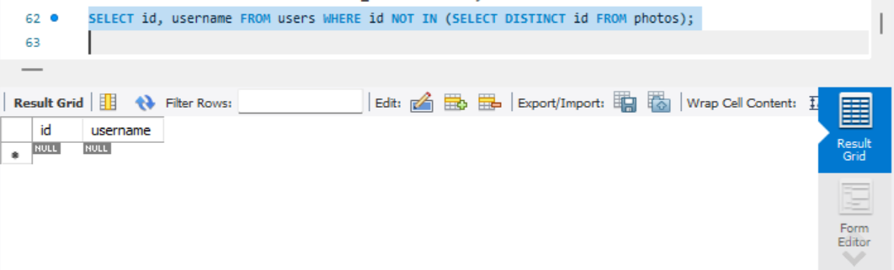

1. **CONTEST WINNER DECLARATION:** The team has organised a contest where the user with most likes on a single picture wins.

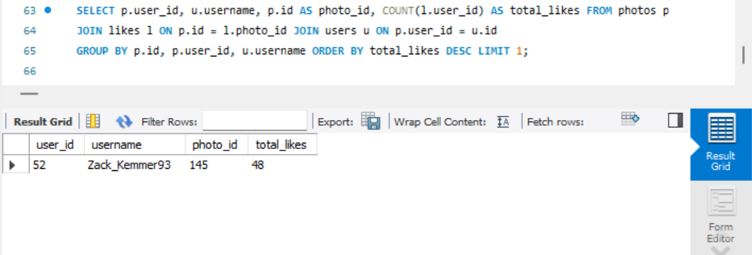

1. **HASHTAG RESEARCH:** A partner brand wants to know the most popular hashtags to use in their post to reach the most people.

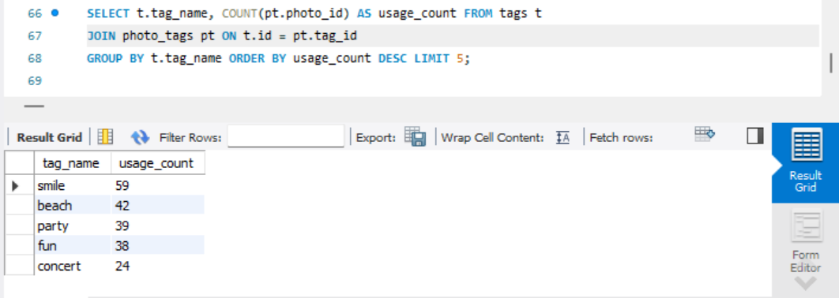

1. **AD CAMPAIGN LAUNCH:** The team wants to know the best day of the week to launch ads.

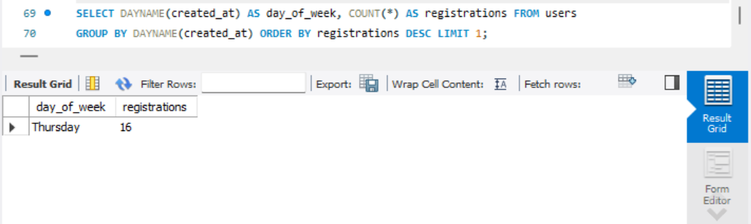

TASK 4- INVESTOR METRICS

1. **USER ENGAGEMENT:** Investors want to know if users are still active and posting on Instagram or if they are making fewer posts.

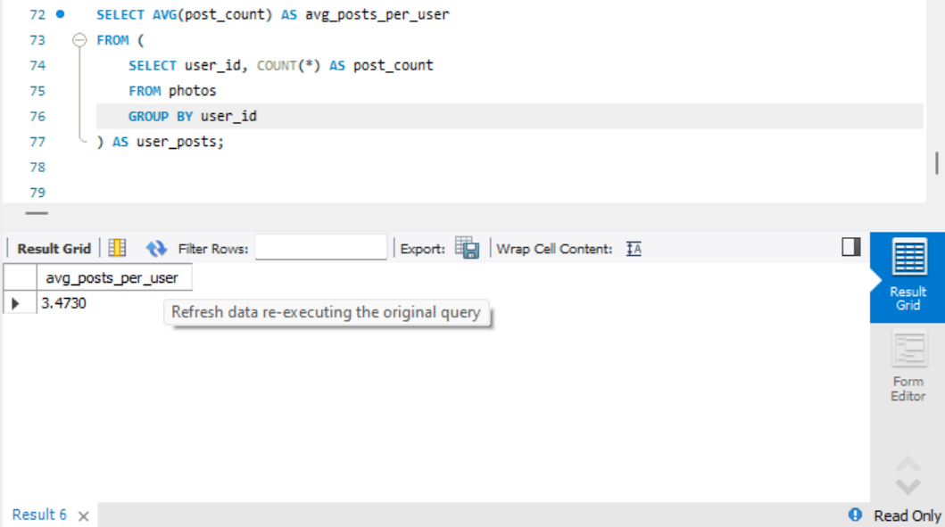

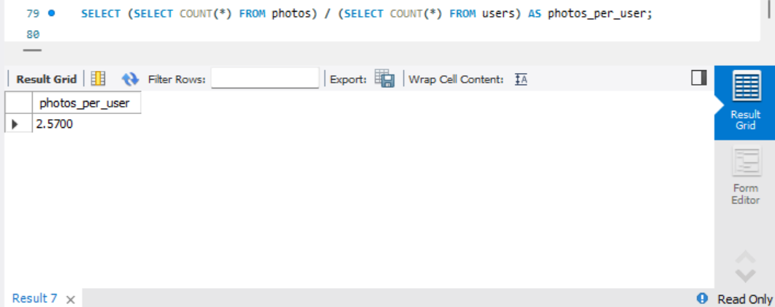

1. **Bots and Fake Accounts:** Investors want to know if the platform is clouded with fake and dummy accounts.

